**CSE 303L: Data Communication and Computer Networks**

**Lab01**

**Fall 2024**

Submitted by: **Mohsin Sajjad**

Registration No: **22pwsce2149**

Class Section: **A**

“On my honor, as student of University of Engineering and Technology, I have neither given nor received unauthorized assistance on this academic work.”



Student Signature: ______________

Submitted to:

**Dr. Yasir Saleem Afridi**

Month Day, Year (26 02, 2025)

Department of Computer Systems Engineering

University of Engineering and Technology, Peshawar

**Lab 01**

**PC Network TCP/IP Configuration**

**OBJECTIVES OF THE LAB**

Following topics will be covered in this lab

1. Gather information including connection, host name, Layer 2 MAC address and Layer 3 TCP/IP network address information.
2. Compare network information to other PCs on the network.
3. Identify tool used for discovering a computer’s network configuration.

**Step 1**

Establish and verify connectivity to the Internet. This ensures the computer has an IP address.

**Step 2**

Use the Start menu to open the Command Prompt, an MS-DOS-like window. Press Start >

The following figure shows the Command screen. Type ipconfig and press the Enter key. The

spelling of ipconfig is critical while case is not. It is short for IP Configuration.

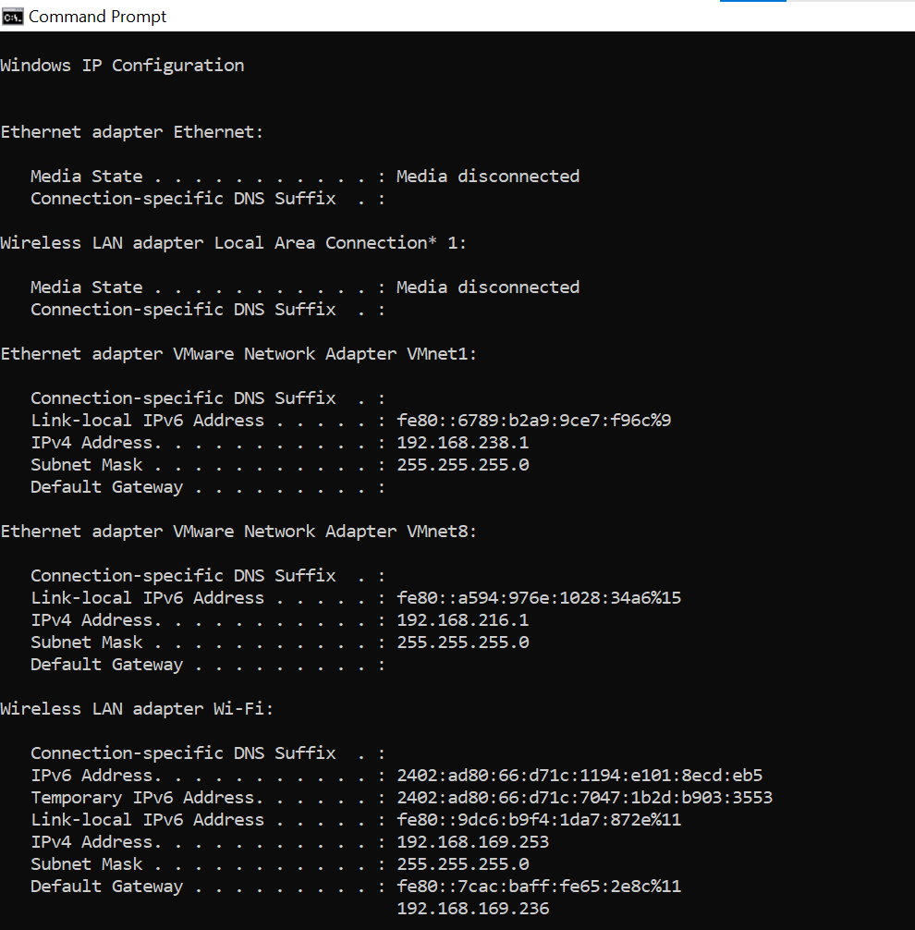

**Step 3**

Record the following TCP/IP information for at least three computers.

|  |  |  |  |
| --- | --- | --- | --- |
|  | Computer 1 | Computer 2 (Neighbor 1) | Computer 3 (Neighbor 1) |
| IP Address | 192.168.239.153 | 192.168.243.149 | 192.168.160.40 |
| Subnet Mask | 255.255.255.0 | 255.255.255.0 | 255.255.255.0 |
| Default Gateway | 192.168.239.1 | 192.160.243.1 | 192.168.160.1 |
| DNS Address | 192.168.239.121 | 192.168.239.121 | 192.168.239.121 |
| DHCP Address | 192.168.100.121 | 192.168.100.153 | 192.168.100.153 |

**Step 4**

Compare the TCP/IP configuration of this computer to others on the LAN

If this computer is on a LAN, compare the information of several machines.

Are there any similarities?

**Ans:** Yes, the machines will have similar IP addresses, subnet masks, and default gateways as they are part of the same Local Area Network (LAN).

What is similar about the IP addresses?

**Ans: They all start with 192.168.1.** This indicates they are all within the same private network range, specifically the 192.168.1.0/24 subnet.

What is similar about the default gateways?

**Ans:** The default gateway is usually the same for all devices on a LAN because it’s the IP address of the router or network device that connects the local network to external networks

The IP addresses should share the same network portion. All machines in the LAN should share

the same default gateway.

Record a couple of the IP Addresses:

________________________________________________________________________

**Step 5**

Check additional TCP/IP configuration information

To see detailed information, type ipconfig /all and press Enter. The figure shows the detailed IP

configuration screen.

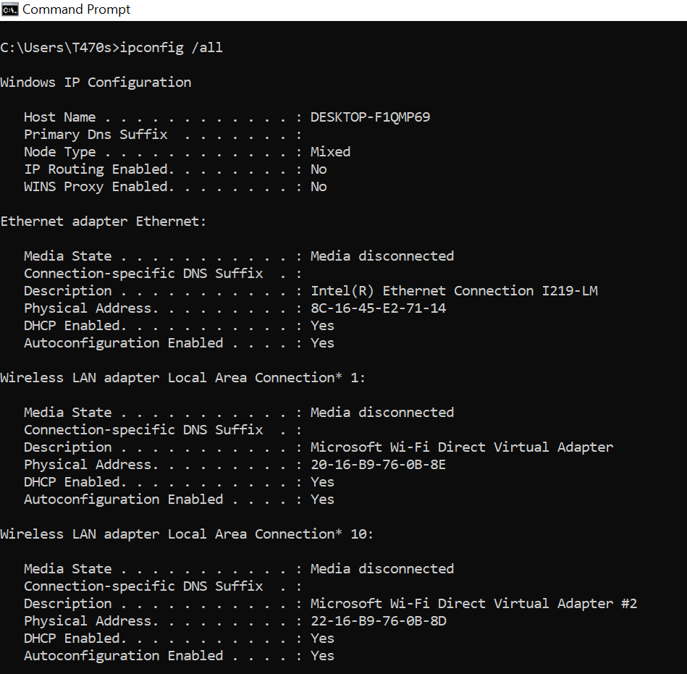

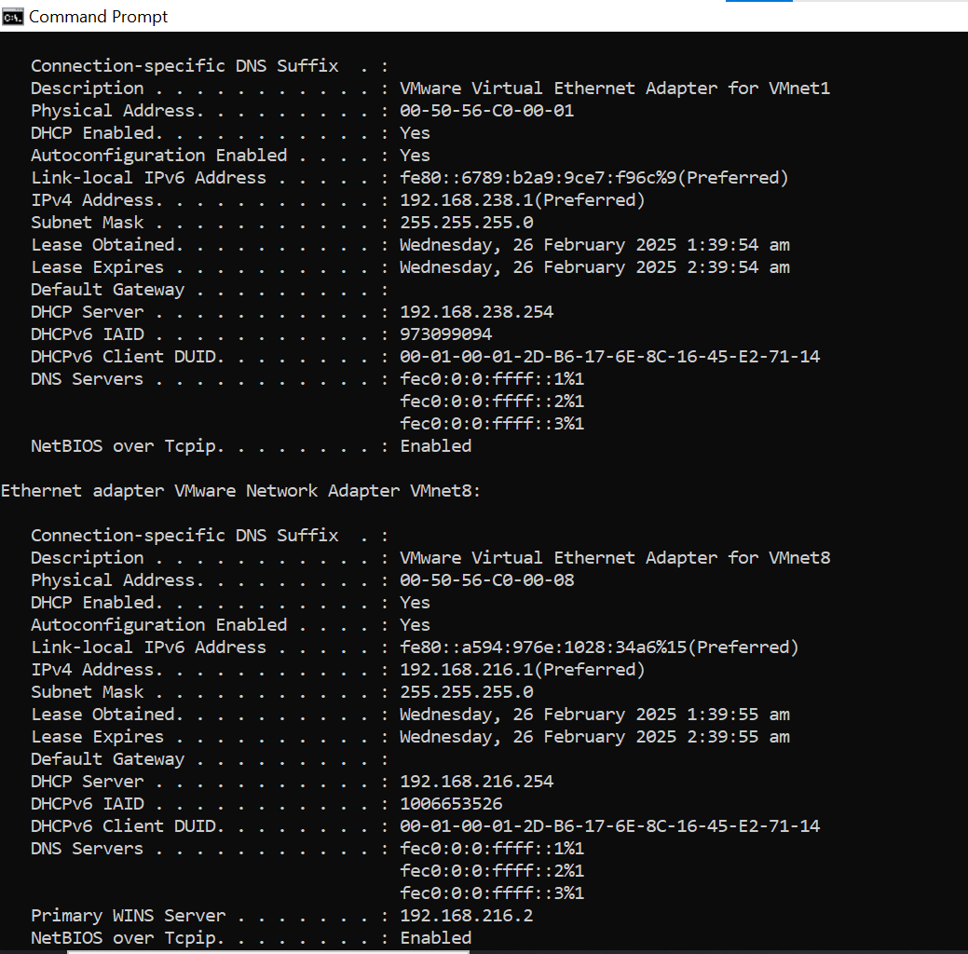

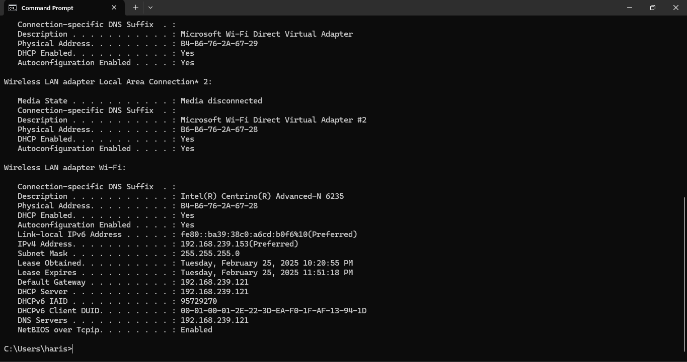

Notice the Physical Address (MAC) and the NIC model (Description).

**Ans:** **Physical address (MAC):** 8C-16-45-E2-71-14,

**NIC model**: Intel(R) Ethernet Connection I219-LM

Write down the IP addresses of any servers listed:

**Ans:** **IPv4 Address**: 192.168.238.1(Preferred)

Write down the computer Host Name:

**Ans:** **Host name:** DESKTOP-F1QMP69

Write down the Host Names of a couple other computers:

**Ans:**

Computer 1: DESKTOP-T3I4Q71

Computer 2: DESKTOP-K3R4TSE

Do all of the servers and workstations share the same network portion of the IP address as the

student workstation?

**Ans:** Yes, they likely share the same network portion (192.168.1).

It would not be unusual for some or all of the servers and workstations to be in another network.

It means that the computer default gateway is going to forward requests to the other network.

**Step 6**

Close the screen when finished examining network settings.

Repeat the previous steps as necessary. Make sure that it is possible to return to and interpret this

screen.

Based on observations, what can be deduced about the following results taken from three

computers connected to one switch?

Computer 1

IP Address: 192.168.5.13

Subnet Mask: 255.255.255.0

Default Gateway: 192.168.12.1

Computer 2

IP Address: 192.168.5.5

Subnet Mask: 255.255.255.0

Default Gateway: 192.168.12.1

Computer 3

IP Address: 192.168.11.97

Subnet Mask: 255.255.255.0

Default Gateway: 192.168.12.1

Should they be able to talk to each other?

**Ans:** Computer 1 and computer 2 are on the same network but computer three is on different network, so direct communication is not possible without a router.

Are they all on the same network? Why or why not?

**Ans:** No. They are not on the same network because their IP addresses have different network portions (192.168.5.x and 192.168.11.x)